**Servo Motor**

**Introduction**

A servo motor is a [rotary actuator](https://en.wikipedia.org/wiki/Rotary_actuator) that allows for precise control of angular or linear position, velocity and acceleration. It consists of a suitable motor coupled to a sensor for position feedback. It also requires a relatively sophisticated controller, often a dedicated module designed specifically for use with servomotors.

Servo is a general term for a closed loop control system. A closed loop system uses the feedback signal to adjust the speed and direction of the motor to achieve the desired result.

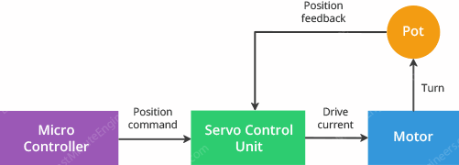

**Working of Servo Motor**

A **Servo Motor** is a small device that has an output shaft. This shaft can be positioned to specific angular positions by sending the servo a coded signal.

The **Servo Motor** has some control circuits and a potentiometer (a variable resistor, aka pot) connected to the output shaft. In the picture above, the pot can be seen on the right side of the circuit board. This pot allows the control circuitry to monitor the current angle of the servo motor.

If the shaft is at the correct angle, then the motor shuts off. If the circuit finds that the angle is not correct, it will turn the motor until it is at a desired angle. The output shaft of the servo is capable of traveling somewhere around 180 degrees. Usually, it is somewhere in the 210-degree range, however, it varies depending on the manufacturer. A normal servo is used to control an angular motion of 0 to 180 degrees. It is mechanically not capable of turning any farther due to a mechanical stop built on to the main output gear.

The power applied to the motor is proportional to the distance it needs to travel. So, if the shaft needs to turn a large distance, the motor will run at full speed. If it needs to turn only a small amount, the motor will run at a slower speed. This is called **proportional control.**

**Pinout of Servo Motor**

Servo motors have three wires: power, ground, and signal. The power wire is typically red, and should be connected to the 5V pin on the Arduino board. The ground wire is typically black or brown and should be connected to a ground pin on the board. The signal pin is typically yellow or orange and should be connected to PWM pin on the board.

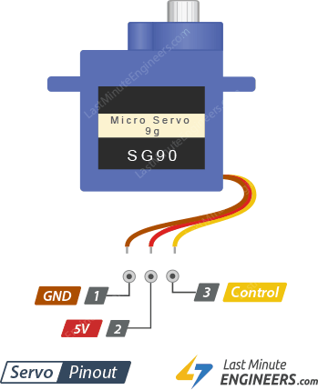

GND is a common ground for both the motor and logic.

5V is a positive voltage that powers the servo.

Control is input for the control system.